|  |  |  |
| --- | --- | --- |
| **gtu logo.jpg** | **GUJARAT TECHNOLOGICAL UNIVERSITY**  **Chandkheda, Ahmedabad**  **Affiliated** |  |

**VISHWAKARMA GOVT. ENGG. COLLEGE, CHANDKHEDA**

**A Project Report**

**on**

**‘WEBI GROCERS’**

**Under the subject of**

**Design Engineering – I B**

**B.E. II, Semester-IV**

**(Information Technology Department)**

**Submitted By Group ID: 164322**

**Pandya Krishna (170170116023)**

**Parmar Fenil (170170116027)**

**Patel Aman (170170116028)**

**Reddiar Harsh (170170116047)**

**Guided By**

**Prof. Jignesh Vania**

**Assistant Professor**

**Academic Year 2018-2019**

**Our project fulfill the needs of:-**

* Time efficient
* Door step service delivery
* Wastage eliminated
* Opportunity to local vendors
* Crowding avoided
* Digital & cod payments
* Attractive interface
* Discrimination is eradicated
* Each vendor gets equal opportunity
* **Design Thinking:**

**Design thinking is generally defined as an analytical and creative process that engages a person in opportunities to experiment,create and prototype models,redesign etc. It draws upon logic, imagination, invitation and systematic reasoning to explore possibilities of what would be and create desired outcomes that benefits end users.**

**It requires good observation skills. We may find new problems in our society of which we were earlier obscure.**

**Snapshots: =>**

**Home page of our project**

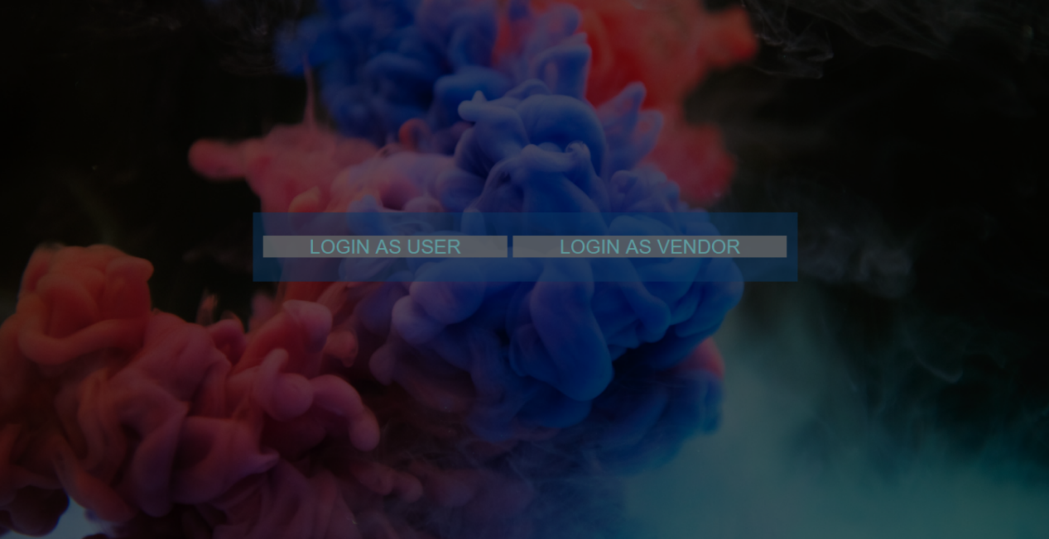

Login page of our product

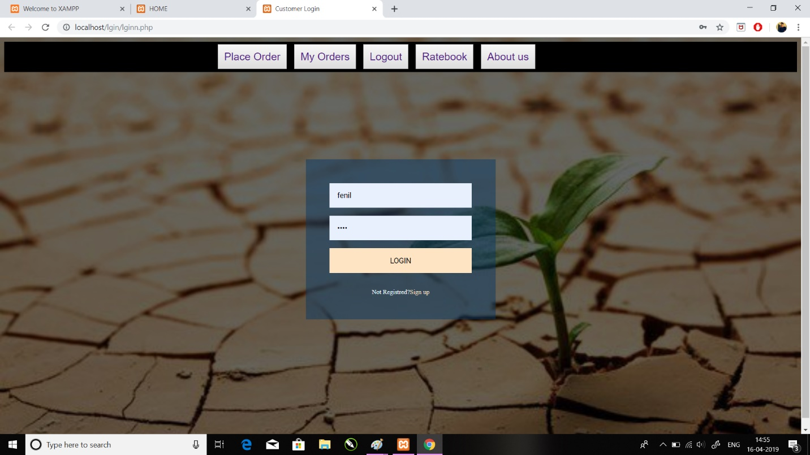

**Page where order is to be placed**

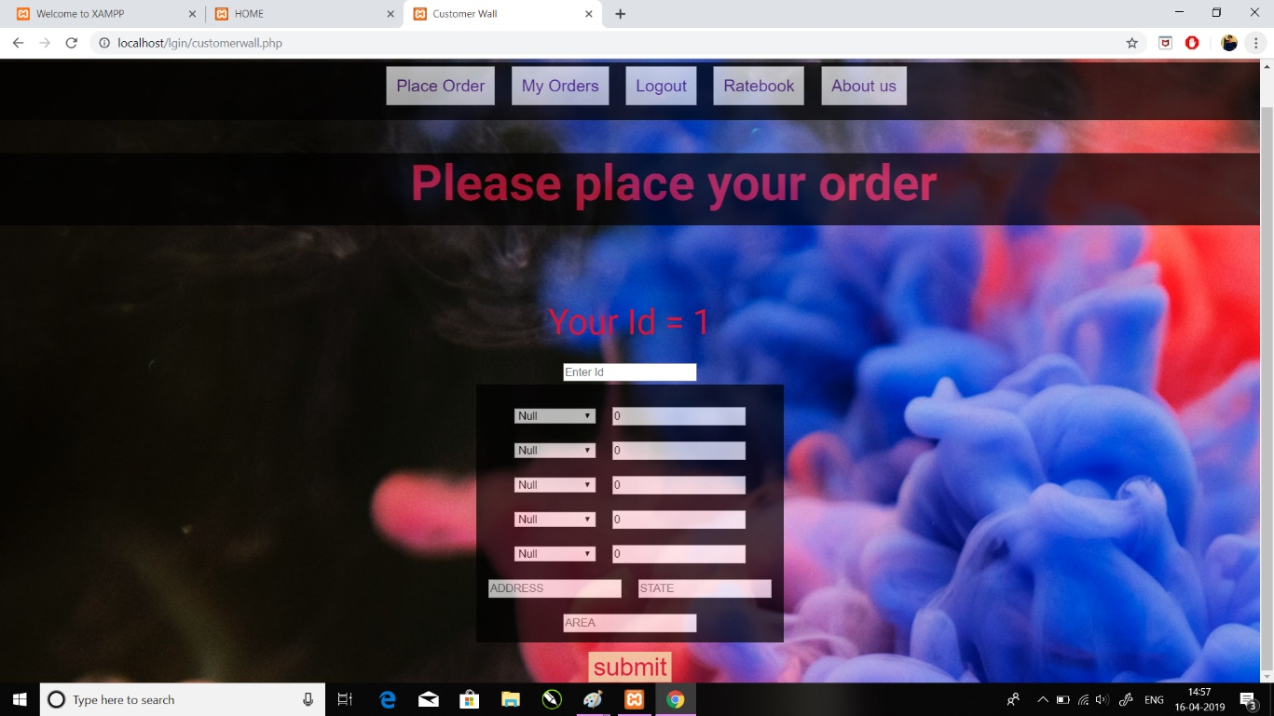

**Order wall**

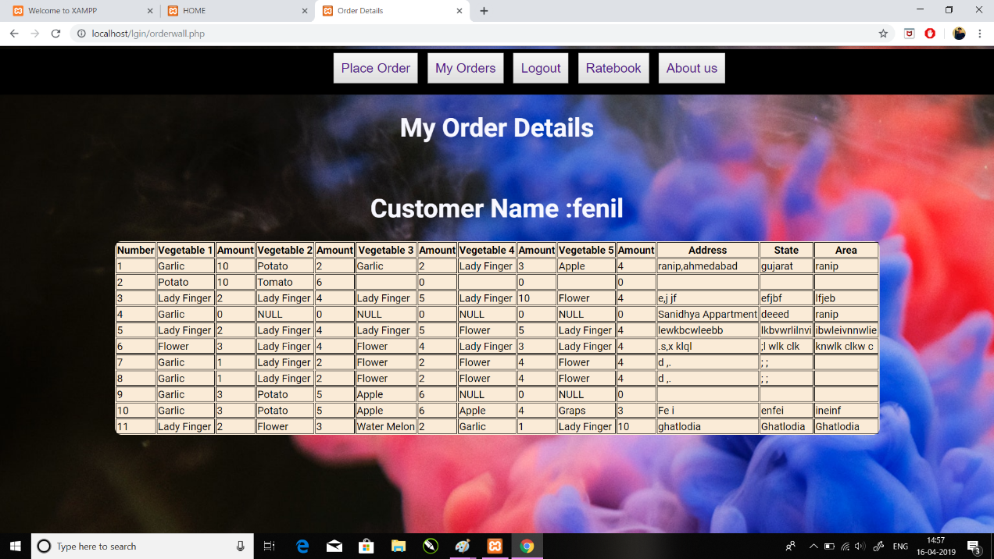

**1)AEIOU Canvas:**

**AEIOU is an investigative tool to help interpret observations gathered by ethnographic practices in the field.**

* **Activities :**

**Planning: It includes planning about estimating definite quantity of vegetables and algorithm for distribution of orders among different vendors.**

**Collecting information about vendors: Gathering information about the vendors interested for the project and explaining them the importance of this project.**

**Promotion: The company has effective promotion policy for promoting this product.**

**Managing and delivering order: It eliminates discrimination among the vendors so each and every vendor is been given equal importance.**

**Tracing location: It provides live location of vendors to provide time efficient service to the customers.**

**Introducing helpline numbers: We will introduce helpline numbers for better service to the customer.**

**Managing Quality: Surprise check about quality will be done at regular intervals to maintain the quality of product.**

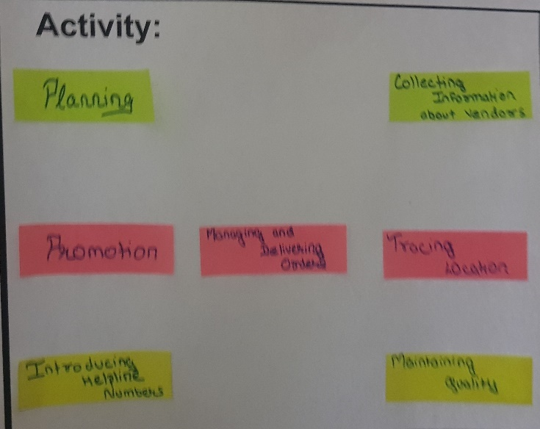

* **Environment: Clean, Liberal, Work friendly, Co-ordination among vendors, Polite , Time saving**

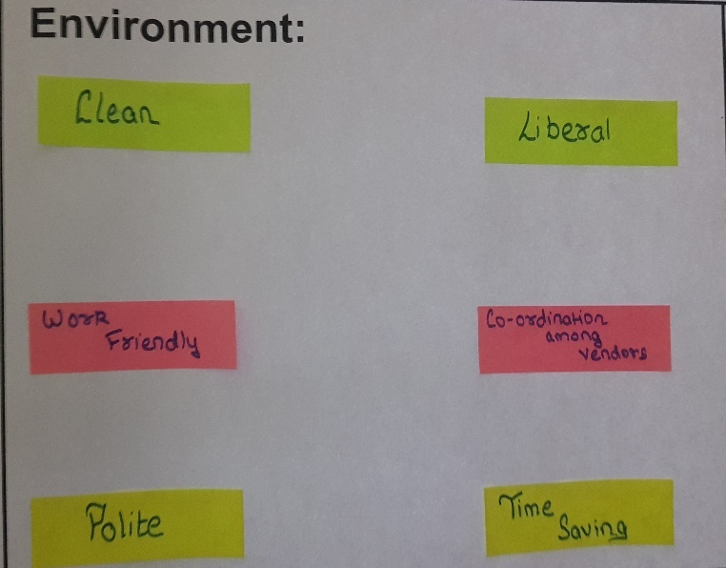

* **Interaction: Admin-vendor, Vendor-Vendor, Admin-Customer, Customer-Vendor, Customer-Customer**

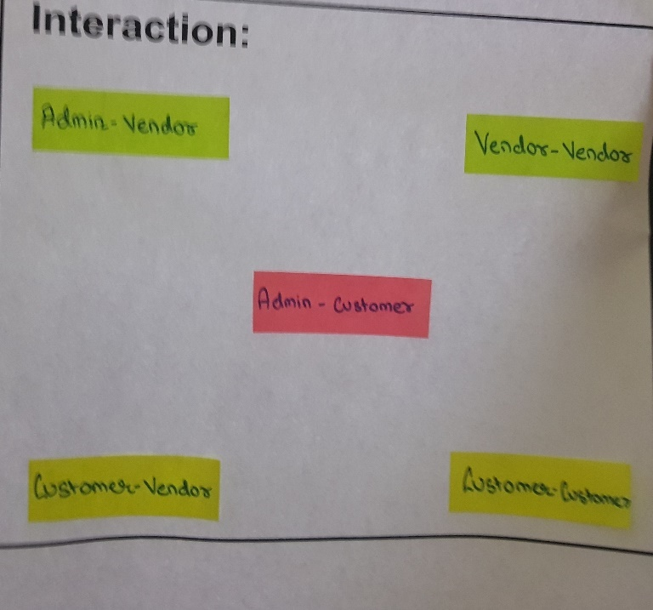**,**

* **Objects: Laptops, Vegetables, High speed internet, Digital payment method, Vehicles for transportation, Mobiles for customers, Mobiles for vendors.**

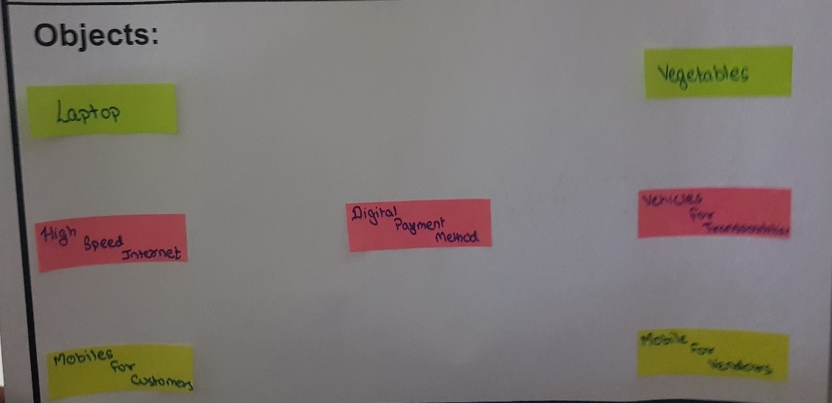

* **Users: Admin, Vendor, Transporters, Customer, Developers**

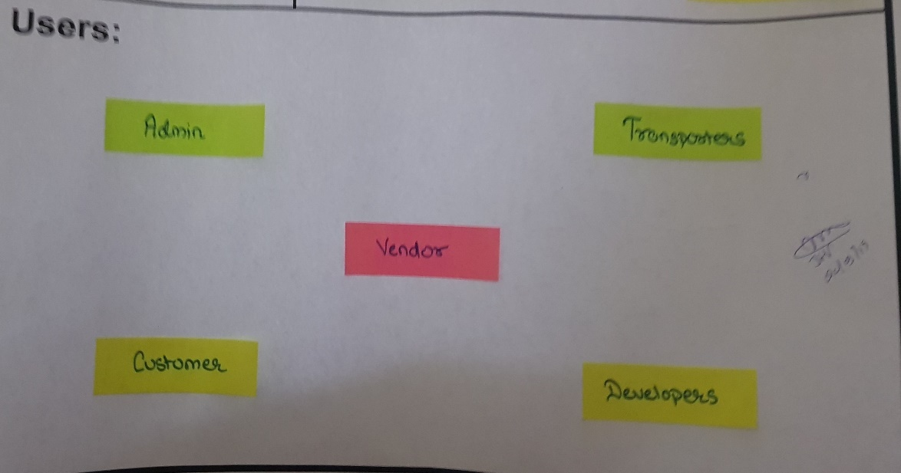

**2)MIND MAPPING:**

* **A mind map is a diagram used to visually organize information.A mindmap is hierarchical and shows relationships among pieces of the whole.Mind mapping is a way to get all of the ideas in your head down onto paper.**

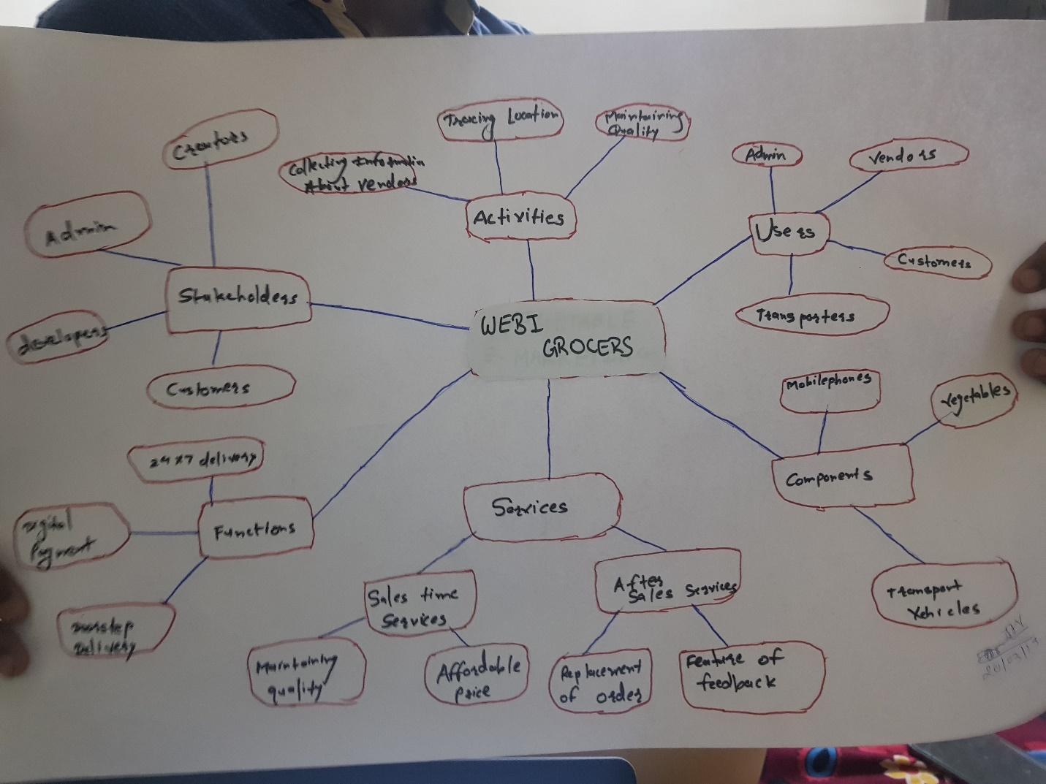

**3)Empathy Mapping:**

* **Domain : General People & Vendor**
* **Users : Admin, Developers, Customer, Vendor, Transporters.**
* **Stakeholders : Creators, Developers, Vendors, Admin, Customers.**

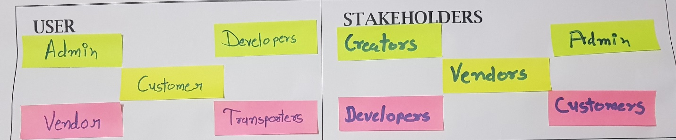

* **Activities :**

**Planning: It includes planning about estimating definite quantity of vegetables and algorithm for distribution of orders among different vendors.**

**Collecting information about vendors: Gathering information about the vendors interested for the project and explaining them the importance of this project.**

**Promotion: The company has effective promotion policy for promoting this product.**

**Managing and delivering order: It eliminates discrimination among the vendors so each and every vendor is been given equal importance.**

**Tracing location: It provides live location of vendors to provide time efficient service to the customers.**

**Introducing helpline numbers: We will introduce helpline numbers for better service to the customer.**

**Managing Quality: Surprise check about quality will be done at regular intervals to maintain the quality of product.**

* **Story Boarding :-**

**Story-1 :-**

**The Customers are really happy. The reason for this is that the customers don’t need to go to buy the vegetables. They receive vegetables at the doorstep. Other benefit is that the problem of change was eliminated due to introduction of digital payment method.**

**Story-2 :-**

**After implementing website, the vendors are really happy as there is no need to load the wheel cart daily and unload it. Even there is no wastage of vegetables because only the required amount of vegetables. All the vendors get equal chance, there is no monopoly.**

**Story-3 :-**

**Some customers felt sad as sometimes the quality of vegetables were not up to mark or there may be a mistake by vendor in delivering the proper quantity of vegetables. Hence the return policy became very difficult as it was time consuming.**

**Story-4 :-**

**It became difficult for the vendors to provide 24*7 delivery to the customers. Problems may also occur to deliver the vegetables in rainy season when the order is placed during heavy rains.**

**Empathy is the ability to understand and share the experience and emotion of another person. The empathy map is a great powerful tool that helps putting yourself inside the head of a person you might be looking.**

**4)Ideation Canvas:**

* **People :**

**Admin, Transporter, Customer, Vendor, Developer**

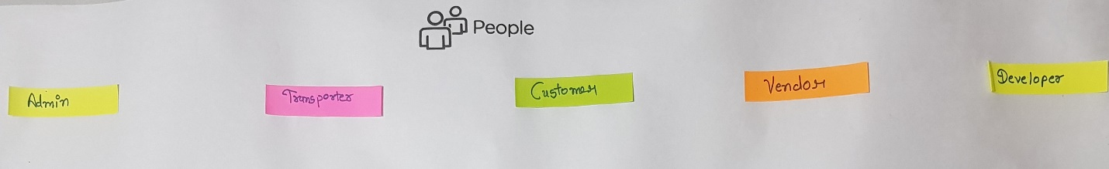

* **Activities :**

**As mentioned earlier activities like Maintaining quality, promotion, introducing helpline number, collecting information about vendors, tracing location, managing and delivering orders, planning.**

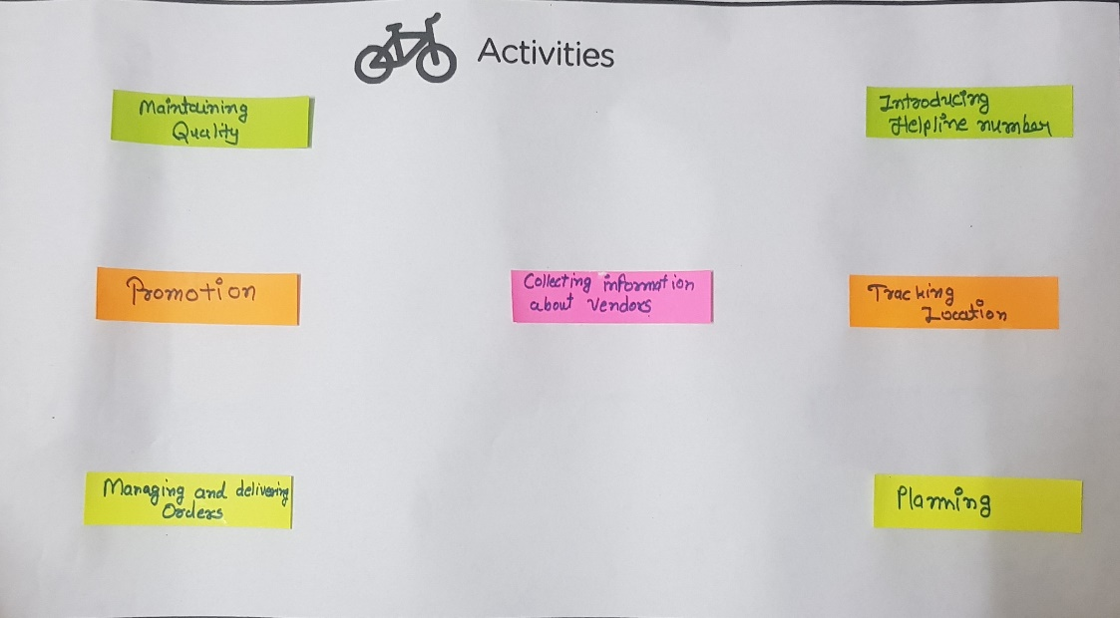

* **Situation/ context / location :**

**The situation faced are live tracking not available, less awareness about technology, unavailability of digital equipments, time consuming return policy, buying comparatively expensive vegetables.**

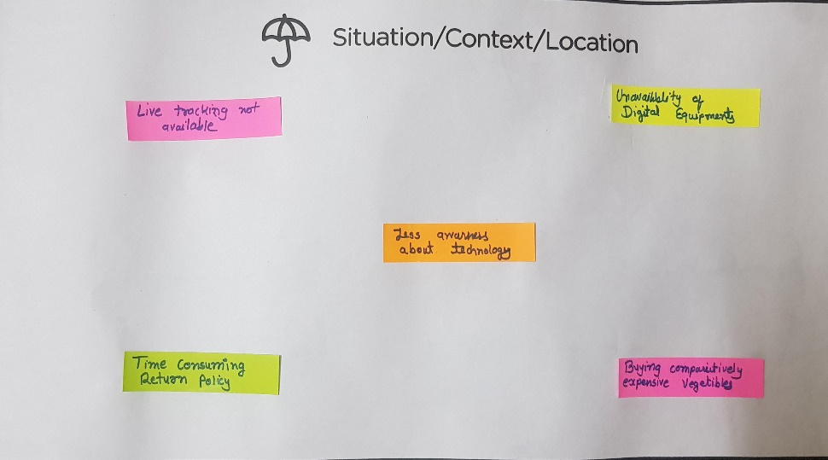

* **Props / Possible Solutions :**

**Possible solutions to the given situations are adding feature of live tracking, spread technology of digital equipments, spread awareness about technology, expand feature of return policy, guide them to distributors.**

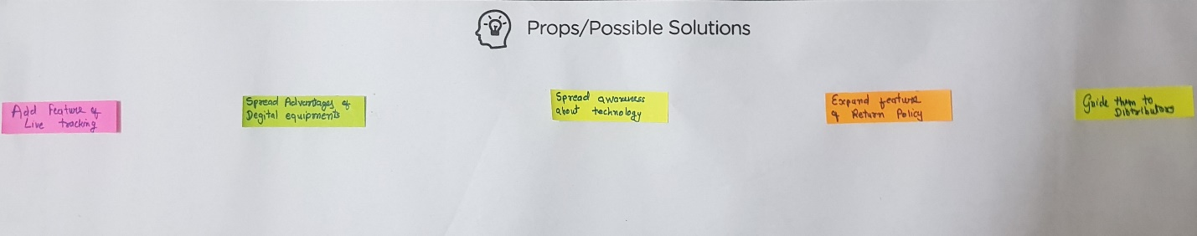

**5)Product Development Canvas:**

* **Purpose :**

**The main purpose of ‘Webi Grocers’ is to provide enhance work efficiency, no wastage of vegetables, doorstep delivery, no need to roam lane to lane, more amount & less work.**

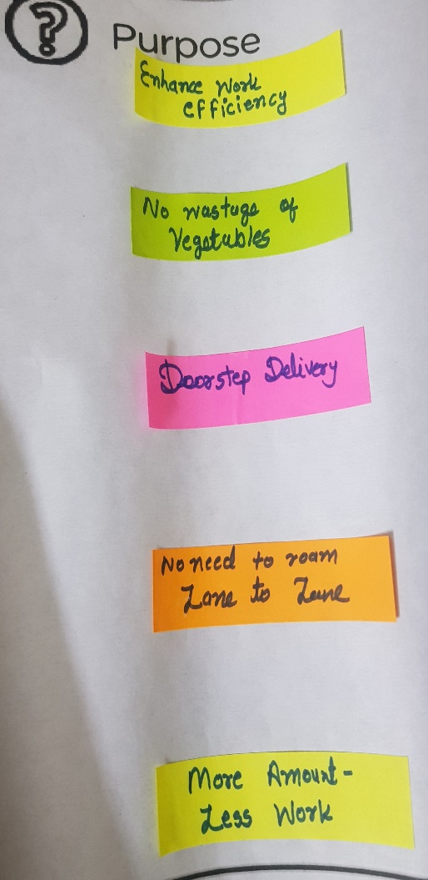

* **People :-**

**As mentioned earlier the people included in this project are customer, vendor, developers, admin, transporter, etc.**

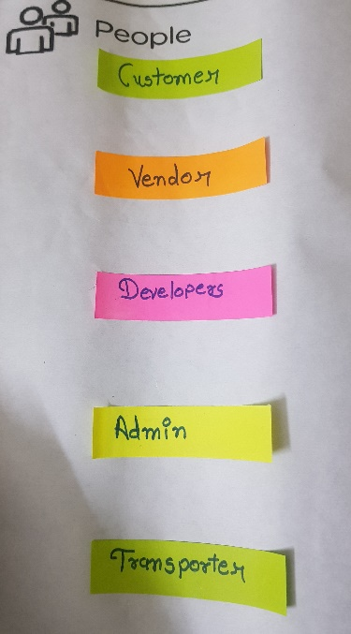

* **Product Experience :**

**The product experience are Product is time saving, easily manageable, long durability, etc.**

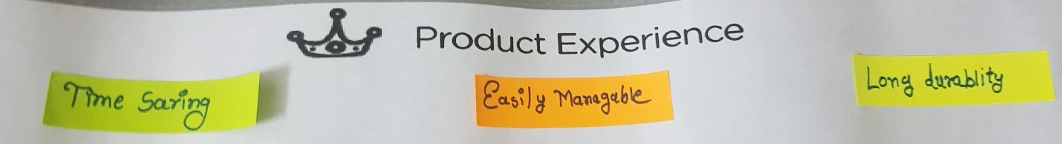

* **Product functions :**

**The product functionality is product is 24*7 delivery, digital payment, doorstep delivery etc.**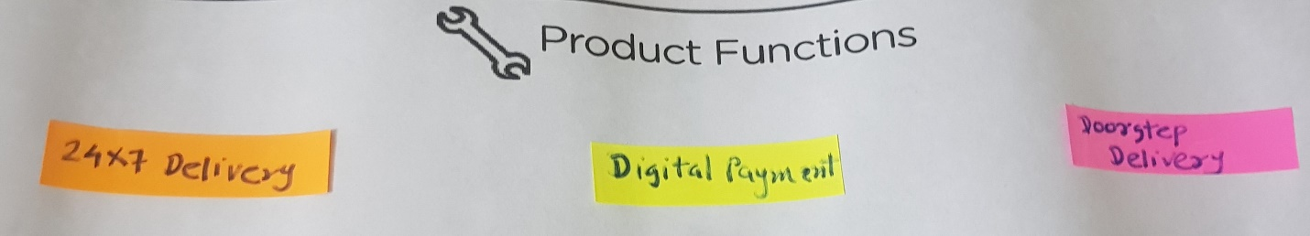

* **Product features :**

**Product features includes some points location tracking, reliable, convenient, able to see history, etc.**

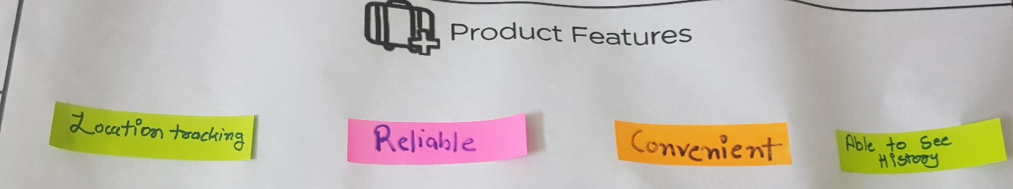

* **Components:**

**The components for the projects are transport vehicles, vegetables, mobile phone, high speed internet connection, mobile among vendor, laptop, etc.**

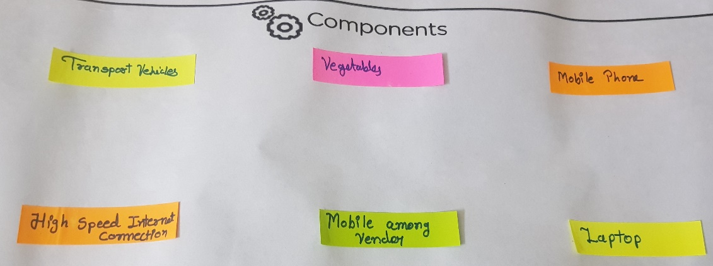

* **Customer revalidation :**

**It includes Less cost, High efficiency, time saving, increased quality, etc.**

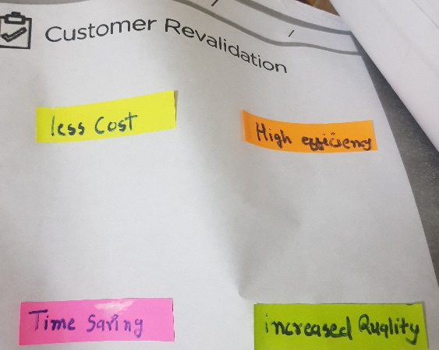

* **Reject / redesign / retain :**

**In this feature to redesign are product has less crowdy environment, attractive UI, no need of working space, environment friendly, spreading awareness.**

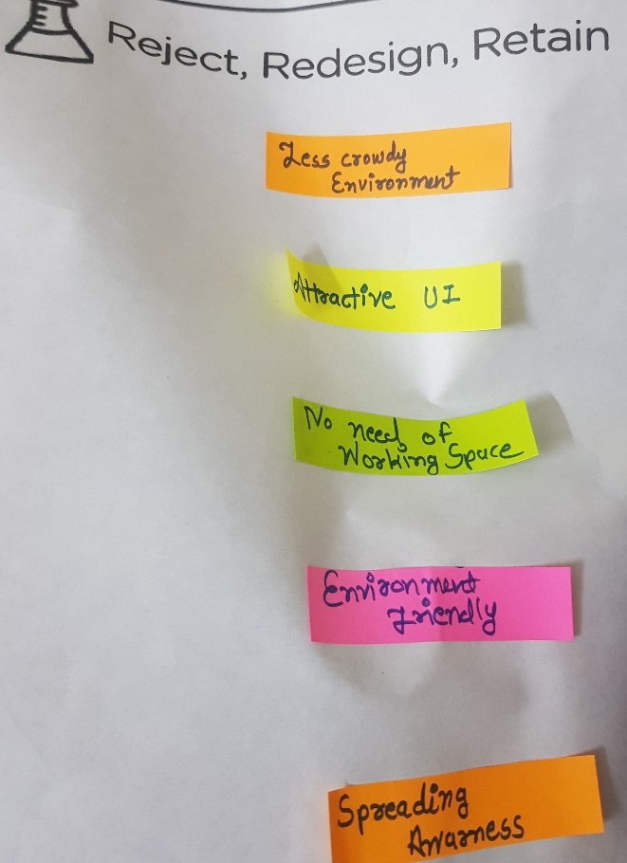

**6)Prototype sheet:**

A prototype is an original model,form or an instance that serves the basis for other processes.In software technology,the term prototype is a working example through which a new model or new version of an existing product can be derived.

The prototype includes following pages:-

* **About us page:-**

Our aim is to provide better facility to our traditional vegetable market to reduce the unnecessary hardwork of vendors and give them ew technology.

* **Main Page:-**

We have provided two options to choose between login as vendor or else login as customer.

* **Ratebook:-**

It gives rates for the different products that are been sold by vendors.

* **Vendor login and registration page:-**

It provides option between login and register. If you have not logged in earlier you need to register initially once.

* **Vendor’s order wall:-**

This page describes the order details about the order that are been placed to a particular vendor.

* **Feedback :-**

Vendors can know the feedback or reviews given by the customer after the service to improve for the next order.

* **Vendor profile:-**

The basic information about the vendor such as name, area, address, vegetables, email-id are shown in this section**.** Also the rating system provided stars are also shown in this part.

* **Customer login:-**

Customer need to select between login and register.

* **Customer order:-**

Customer wall gives the information about customer’s currently placed order and its quantiy and also helps to place order tp the customer

* **Order wall:-**

It details about every order placed previously by customers to till date.

* **Bill:-**

Calculated payment method is being displayed on the screen.

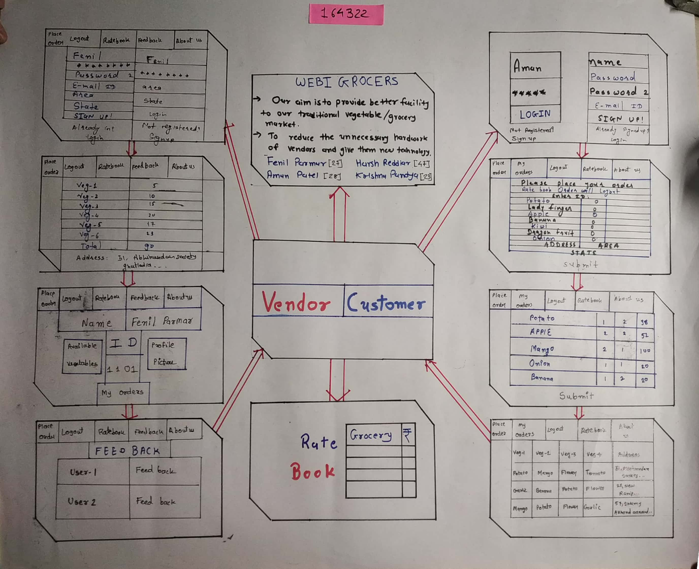

**7) Learning needs matrix sheet:**

The purpose of LNM is to identify the requirements of learning among team members. The team members need to learn and explore a lot of new skills and documents. The centre of sheet contains purpose. It includes exploring requirements in each quadrant representing a specific type of skill acquisition.

* **Tools/methods/application/process involved:**

Our project includes user of PHP myAdmin and database.

* **Application standards and design specifications/principles & experiments:**

Our project has attractive user interface and we have used java script for animation.

* **Software/simulation/skill mathematical requirement:**

We have made our project using brackets and XAMPP to create database and store the data.

* **Components materials strength criteria(exploration- varieties/ testing requirements):**

Basic requirements of our project is laptop/mobile to access our website and with the help of internet connection.

